**Configuring Sound Settings on the 7T Showee/ meduser Computer**

**[Once this has been set up the first time, as long as you plug all the cords into the correct places/ USB ports, these settings should not need to be re-set and it should select the USB (tactors) device as the default whenever you plug it in. However, it is good to check the settings are as expected periodically]**

Type sound settings into the search bar near the windows symbol at the bottom of the screen

Click ‘sound settings’ when it shows up on the menu

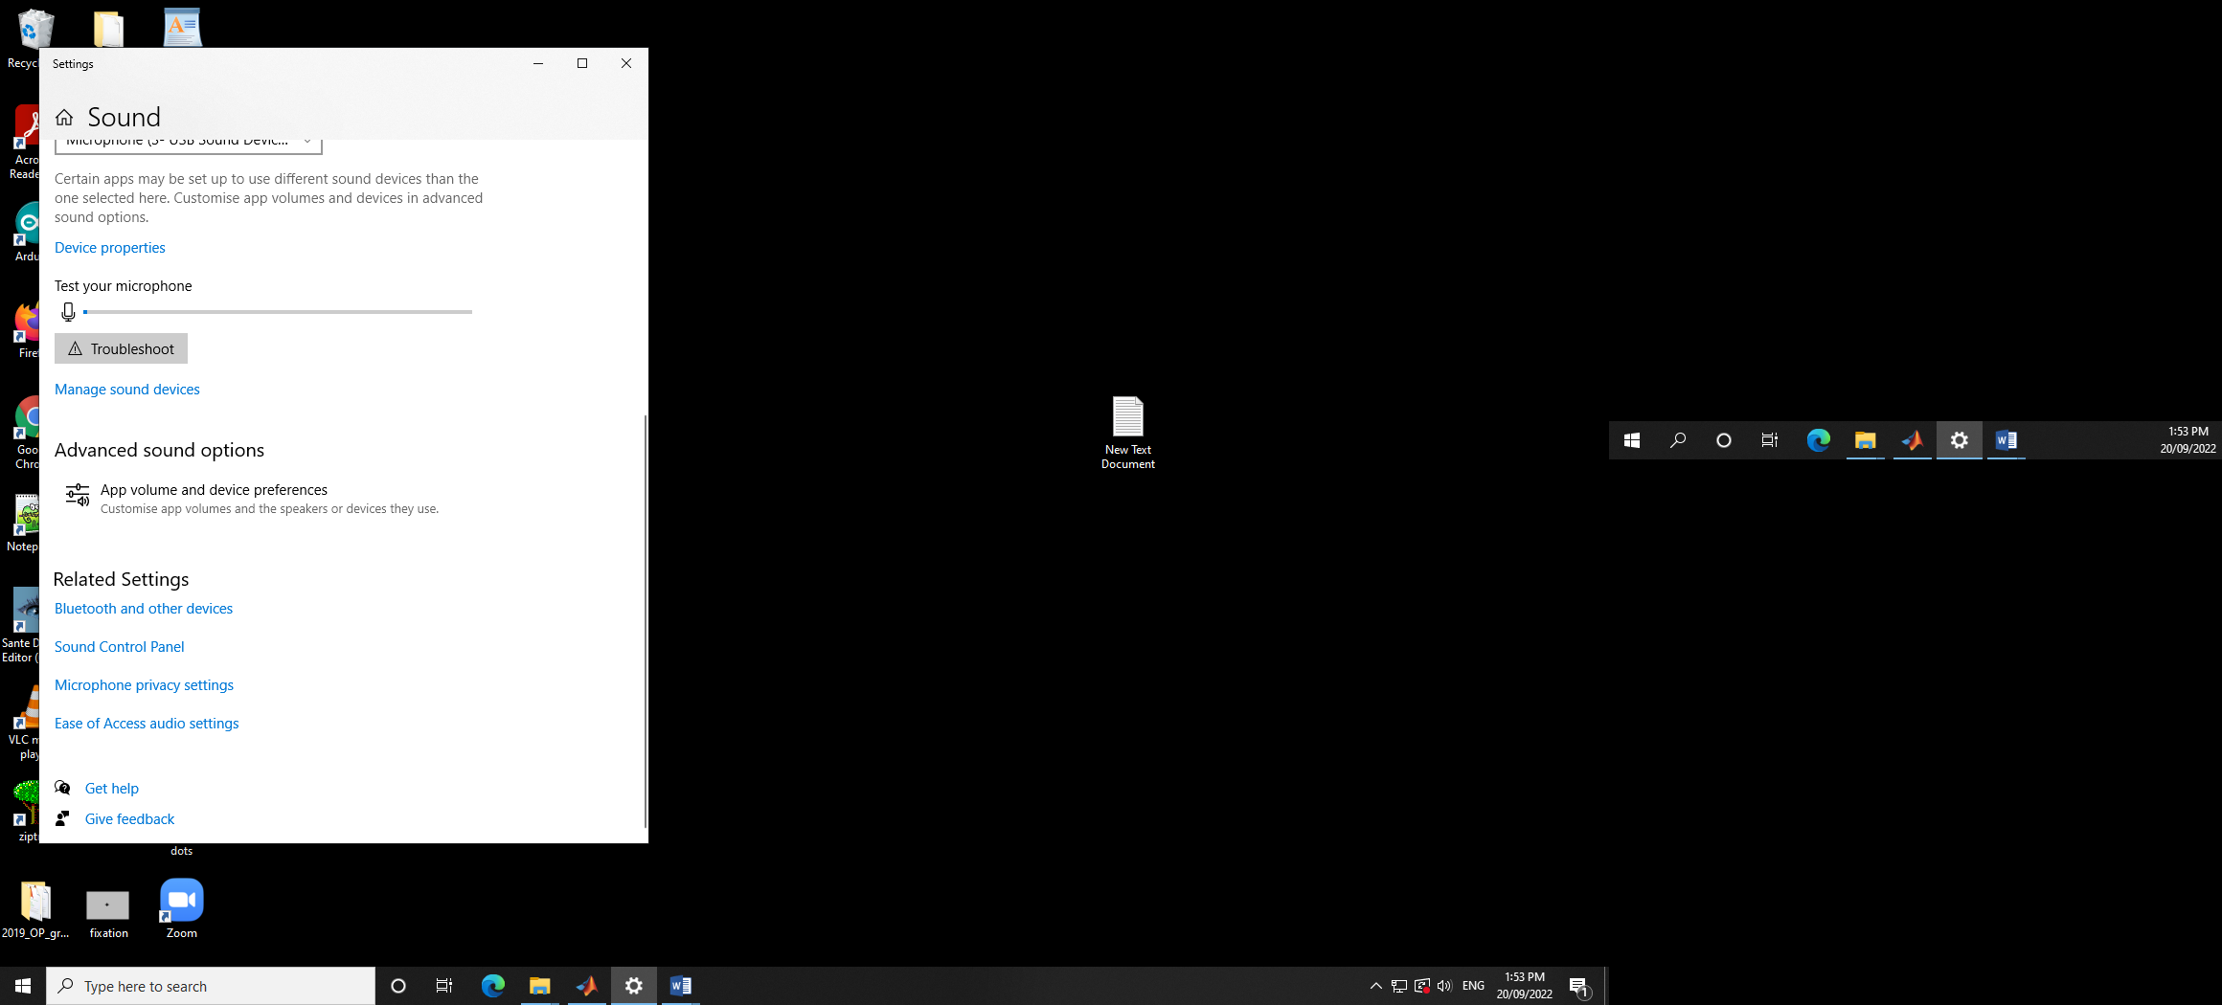

Scroll down to ‘sound control panel’ and click on it

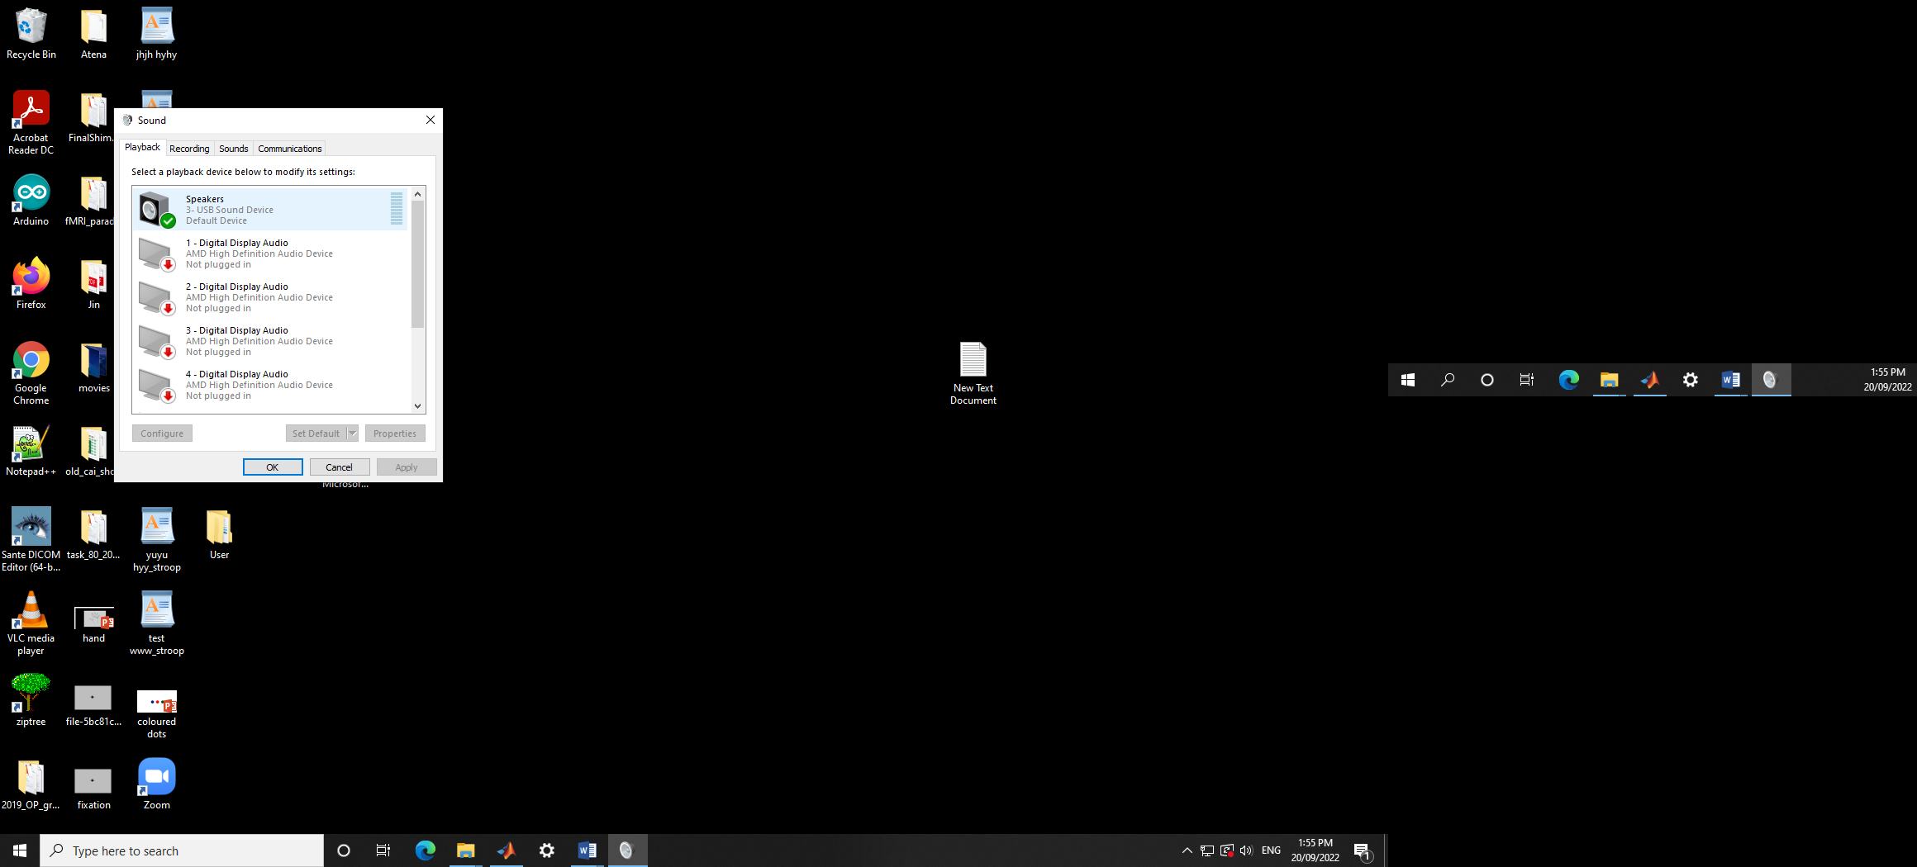

Make sure ‘Speakers, 3 – USB Sound Device, Default Device’ is selected

* It should have a green tick next to its icon

Click on the icon for the USB Sound Device, then click the ‘Configure’ button on the bottom left

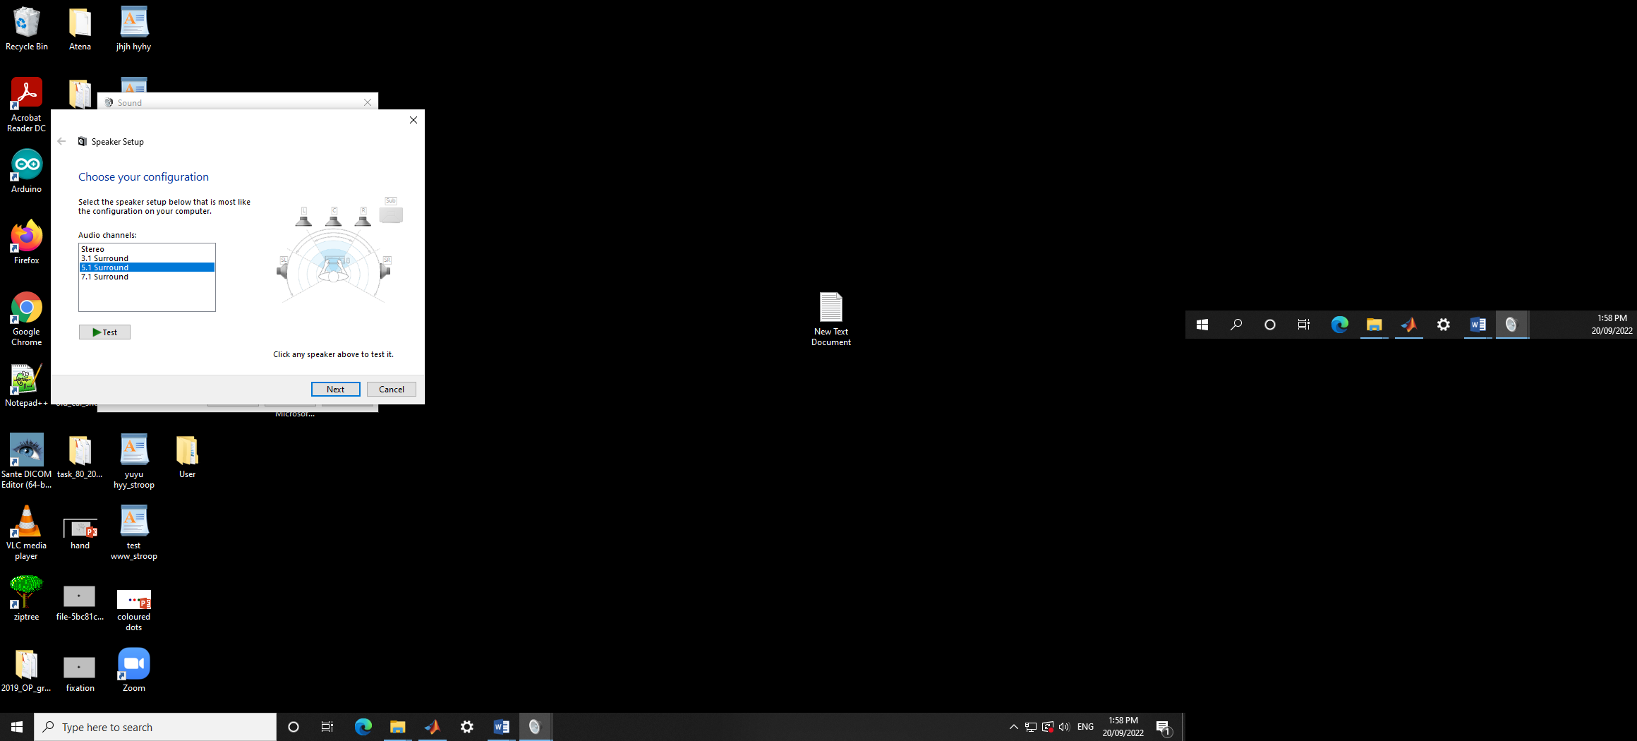

Make sure ‘5.1 Surround’ is selected

* At this stage, if you have your tactors all plugged in and turned on, you can press the images of the speakers on the right hand side. This will play a very quiet sound through the speakers you click on.
  + It’s not very useful as it’s hard to hear
  + It also may not be the right speakers you want, as you may need to turn off speakers (like the subwoofer) at the next step
* Then click the ‘Next’ button

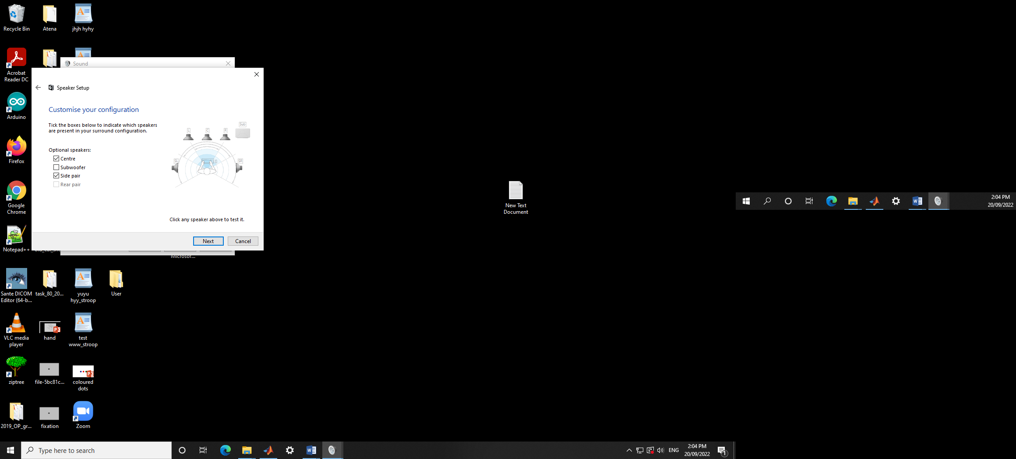

Make sure these are the settings on this screen (by clicking/ unclicking the arrows)

* Centre – ON
* Subwoofer – OFF
* Side pair – ON
  + Then click the ‘Next’ button

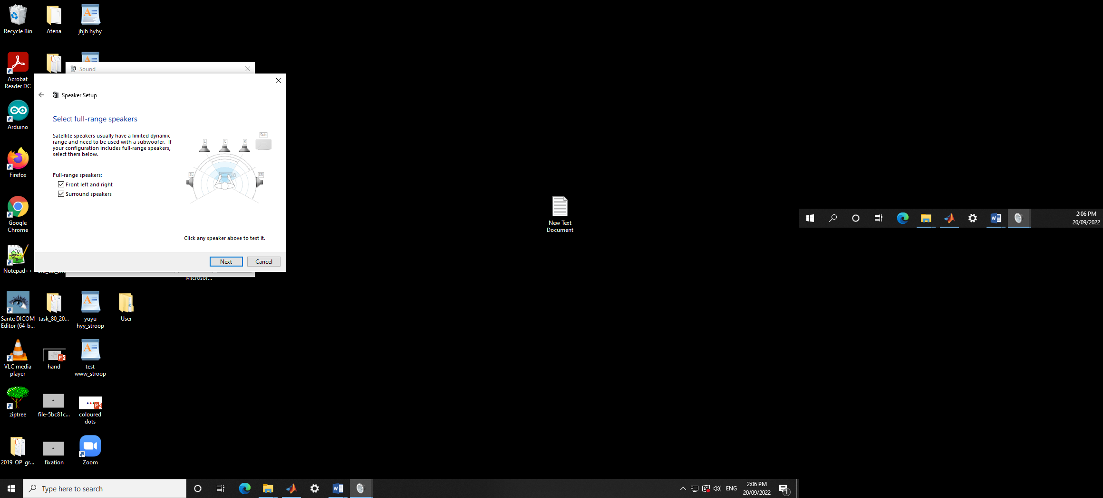

Ensure both arrows are ticked on the ‘Full-range speakers:’ option

* Front left and right – ON
* Surround speakers – ON
  + I actually don’t know what this setting means, but this is what I set it as, for consistency

Closing up

* + Click the ‘Next’ button to go on
  + Then click the ‘Finish’ button to close that dialogue box
  + Click the ‘Ok’ button on the original Sound dialogue box